Alex Kate will quickly build a big fan base that will eagerly swallow whatever new songs she releases - Songweb

Alex Kate’s new single One Plus One is nothing short of magnificent - We Write About Music

Vocally sounding at times like Kate Bush, Alex Kate’s head voice notes are spectacular. Such control and superbly executed delivery across the spectrum - Send me your ears

UKs RISING ARTIST ALEX KATE RELEASES ANOTHER SINGLE
DON’T HOLD BACK FROM UPCOMING EP
REBEL FOR LOVE, OUT 14 OCTOBER

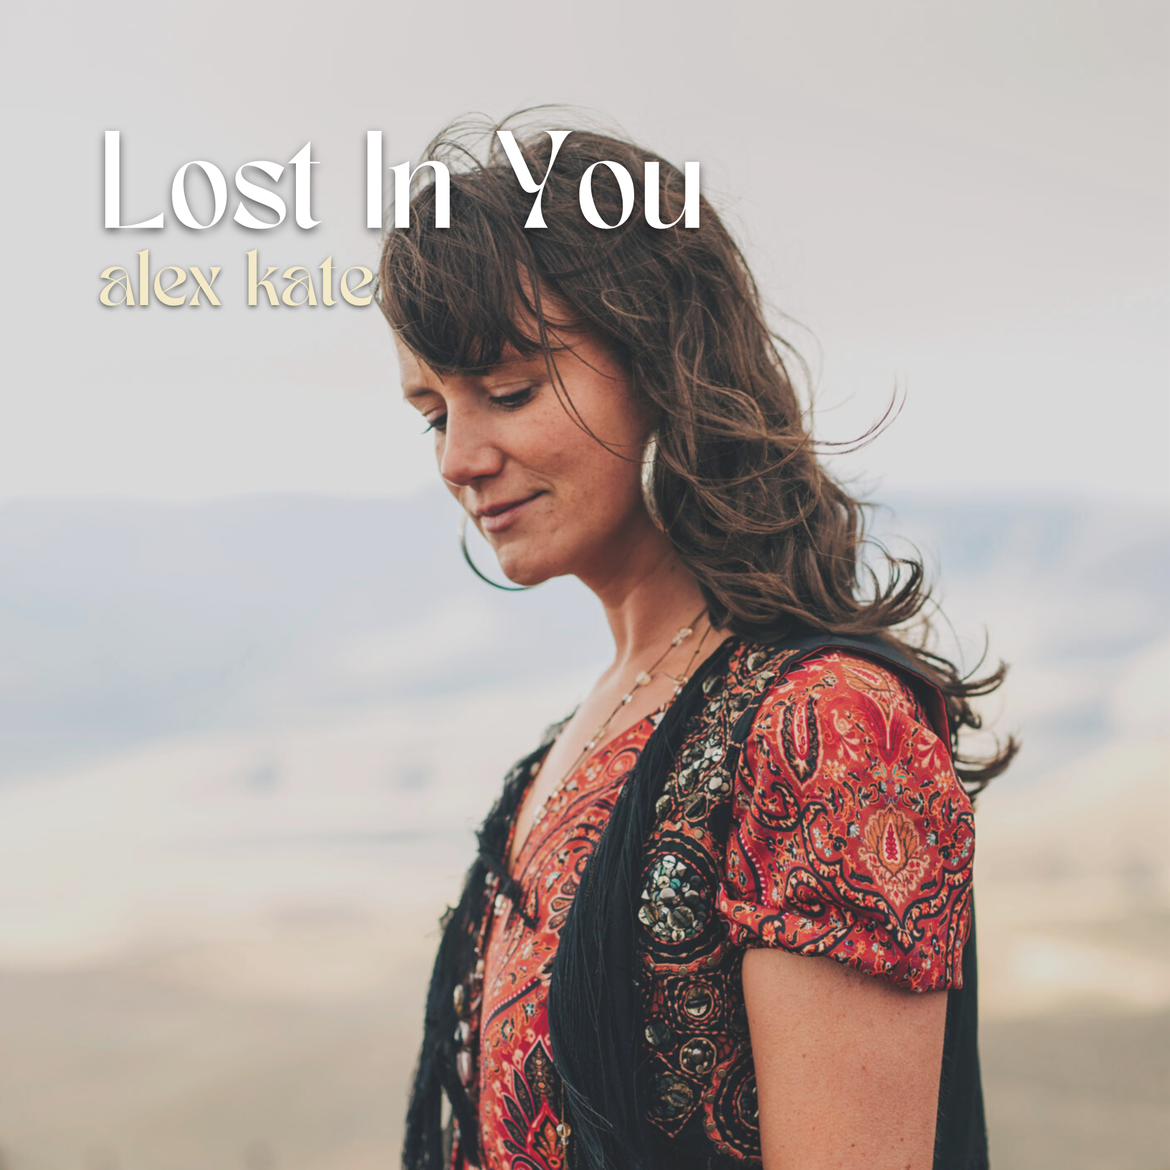

Leading towards the release of her new EP “Rebel For Love,” out 14 October, Alex Kate is happy to share another single Lost in You ahead of its release. Lost In You follows her previous releases, One Plus One and Summer Wagon which were both critically acclaimed by media in the UK and across Europe. You Can listen to it here

Alex wrote Lost in you from start to finish after watching a murder mystery programme, for some unknown reason inspiration hit her and she ran upstairs to my bedroom and quickly recorded it. “You wouldn’t think that a programme about murders would inspire such a love song.. you never known when creative moments are going to hit I guess.”
Alex Kate had sat on this song for a while and hadn’t quite found what it needed to sound like yet. She has “the same feeling about songs as Michael Angelo had about sculptures. Songs are like angels caught in marble and you have to just chip away to release them and some can take more time than others.” She brought Daniel Newcombe (MD for BEKA) into the project in August and he sent me the first demo and she knew that she had finally found the angel. “He created the ethereal dreamscape that I knew i was looking for that reflected the utter abandonment to love.”

She shot the video in Capetown with just an early demo. SheI got a friend Freddie Reed, who is used to shooting for National Geographic onto the project. He had the wild idea to go and shoot the video in two days in the desert and finish at this farm up on a cliff 500 kilometers from cape town. “Sounds great I said to Freddie. I didn’t know that we would be driving through some of the heaviest rain that the Karoo desert has seen in 10 years and get to our final destination and there to be no sunset or stars and a complete white out. However, it was actually the most amazing experience shooting in the desert where Africa Burn happens. Freddie Reed the director wanted to encapsulate the feeling of being lost and lonely in the city and at peace and alive in the desert. I think he has done a magical job.” Preview it here

In order to celebrate the release of her new EP Rebel For Love, Alex will be hosting her EP release party on the 13 October at St. Peters in Notting Hill. Tickets available here.

Listen to Lost In You

For more information:
https://www.alexkatemusic.com/

Tiktok: 12.7k followers
Instagram: 6.1K followers

